RICHARD HILLIKER – A+, MCP, CCNA, CCNA Voice
34 E. Oak ST., Apopka, FL 32703 ▪ richiehilliker@gmail.com ▪ (321) 228-0971

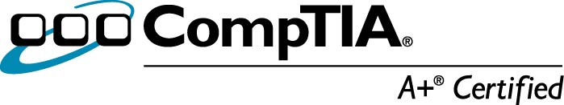
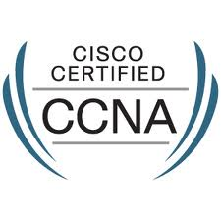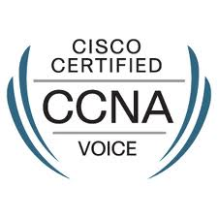

Objective

To attain a technical leadership position with an organization that can use my skilled abilities in troubleshooting, customer service, and attention to detail as a Systems and Network Manager.

EXPERIENCE

I’m a skilled self-starter with industry certifications and over twelve years of proven success supporting the most vital lifeline of an organization – Corporate networks, remote locations, servers and end users.

2014 – Present ▪ Presidio Managed Solutions, Orlando, FL ▪ NOC Engineer

- Work in Network Operation Center trouble shooting, patching and configuring switches, routers and firewalls for the clients on a per instance base
- Received incoming calls from vendors and clients to make sure that the clients have a stable and reliable connection from the vendors.
- Monitored and maintained clients networks remotely to ensure 100% availability and up time.
- Configure devices if the contract allows us to or help clients to configure the device appropriately and as needed for resolve the client issues.
- Escalate to the appropriate team if it is out of our scope to work or trouble shoots.
- Notify the customer promptly of any issue via phone call or email depending on the severity of the ticket, then start to work the issue.
- Seen and have a basic knowledge of the monitoring tool that are used such as Net Cool, Zenoss.

2001 – 2014 ▪ North American Risk Services, Inc., Altamonte Springs, FL ▪ Systems / Network Administrator
TPA ▪ Independent 3rd-party insurance claims administration

- Responsible for all desktop support issues and new user set-up, set-up users in Active Directory, Monitor and maintain GPO’s for our current location, all distributed networks, and remote offices.
- Proven technical lead in managing the communication backbone of our organization: MS Exchange 03, MS Office 03,07 & 10, MS Outlook 03,07 & 10, Windows Server 03 and 08, TCP/IP, A/D, Group Policy, BrightStor Arch Serve, QuickBooks Enterprise, Blackberry Manager, and Cisco VOIP phones.
- Managed and provided service and support for corporate Fax Machines, Copiers, Printers, Exchange Server, Domain Controllers, File Servers, Print Servers, Cisco Call Manager Server, Cisco Unity Server, and Cisco Unified Presence for the call center.
- Responsible for setting up all phones for users in all the office and in all locations. Set up Cisco 7945 and 7965 phone and virtual phones.
- Once the users are created, responsible for maintenance and managing of the phones and users.
- Working knowledge of Cisco switches and routers and instrumental in integrating new office locations with security policies and communication of networks via router to router VPN.
- Responsible for maintaining our Wireless LAN controller working and running.
- Influential member of our security policy enablement by working the Cisco ASA Firewall to allow/disallow traffic according to policy and client needs, such as managing specific application ports.
- Extensive troubleshooting experience with network connectivity for employees and for external clients.
- Consistently top rated in customer service & IT support. Will go out of my way and think “Out-side the box” to help all, such as end-users and field adjusters with laptop issues and network issues.
- Proven enterprise experience: Upgraded over 180 users from W2K /Compaq workstations to WXP and Dell GX620 PCs with dual monitors, and migrated users successfully from XP/Vista to Win 7.
- Wrote procedures and password policies which are being used in employee handbook
- Successfully wired 50+ new ports and quickly deployed three secured wireless network access points.
- Implemented a new sonic wall 4500 for teleworkers and remote users to VPN back into the network to access network resources.
- Responsible for the maintenance of the Barracuda devices. Configure the devices if needed to allow specific emails or web content through or asked by upper management.
- Tasked with researching different video conferencing solutions and then once approved implemented the solution into the organization so that video conferencing can done internally or with external clients and employees.
- Supply Coordinator (1998-2001)
- Maintained responsibility for ordering and purchasing supplies for the Maitland, Sarasota and Tallahassee locations; handled all UPS shipments in and out of the office.
- Was in charge of inventory control and management of all the office needed including office supplies, equipment and furniture
- Was responsible for the maintenance contracts on all the copiers and faxes that the company had.
- Also responsible for the return of leased equipment and for the purchase of new equipment in all the office locations.
- Negotiated the best price from several different vendors and then was responsible for the contracts once they were signed.

TECHNICAL SKILLS

- Systems Administration | - Windows 2K/XP/ WIN7 | - DNS/DHCP/IIS, VPN
- VOIP/802.11 B-G | - MS Office 2003/2007/2010 | - VM Ware / Virtual PC
- Technical Support | - Windows Server 2k/03/08 | - Ghost Clone Application
- Troubleshooting/Diagnostics  - Barracuda Web Filter  - Sonic Wall 4500 Firewall  - Cisco Unified Presence | - Exchange Server 03/07/10  - Barracuda Journaling  - Cisco Call Manager  - Go To Assist | - Cisco Network Devices  - Barracuda Spam & Firewall  - Cisco Unit  - Cisco ASA 5540
- Helpdesk Management  - Symantec Antivirus  - BlackBerry Manager  - Service Now | - Active Directory ▪ TCP/IP  - Solar Winds  - Inter-Tel PBX | - Cisco ASA 5505  - Cisco Call Manager  - Arch serve Backup  - Inventory Management

Education - Certified: CompTIA A+, MCP, CCNA and CCNA-Voice. Attended New Horizons Computer Learning Center (Orlando, FL) Currently studying CCNA-Security and then will work on obtaining my CCNP Certification.

AwardS - 2002 and 2006 ▪ North American Risk Services, Inc, Maitland, FL - Awarded Employee of the Quarter for outstanding customer service, performance, productivity, and dedicated service.

